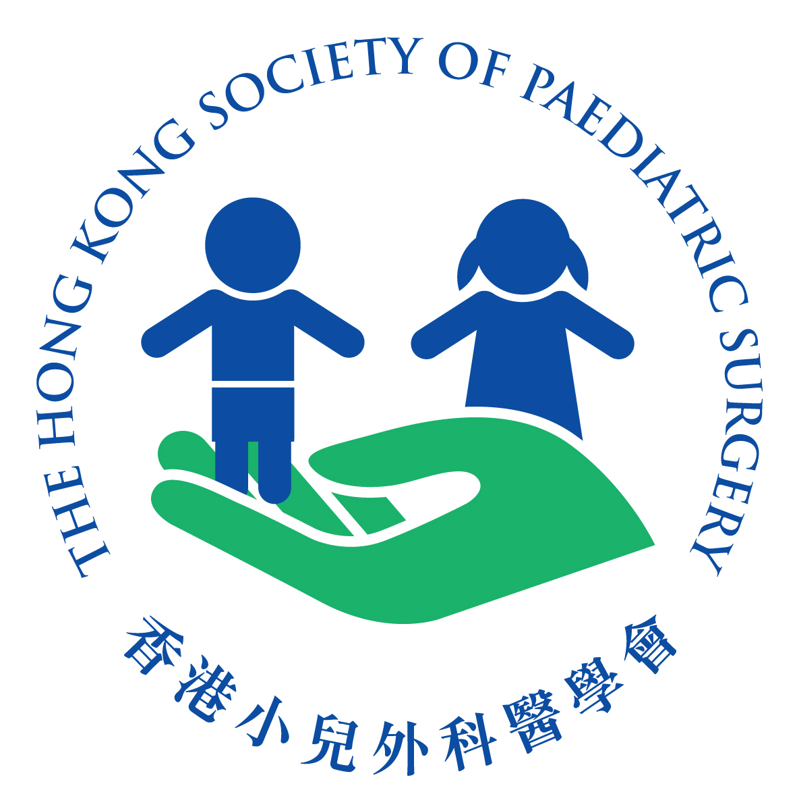 | THE HONG KONG SOCIETY OF PAEDIATRIC SURGERY  Suite 1329, Central Building, 1-3 Pedder Street, Central, Hong Kong  Fax: 28696916
President  Dr. Kelvin K W LIU  Vice President  Dr Peter YH TAM  Honorary Secretary  Dr Kenneth L Y CHUNG  Honorary Treasurer  Dr. Jennifer D Y SIHOE  Council Members  Dr Edwin KW CHAN  Dr Ivy H Y CHAN  Dr Michael W Y LEUNG  Prof Kenneth KY WONG | 15th February 2016  Dear colleagues,  You are cordially invited to participate in the 2nd Annual Scientific Meeting and Urodynamic Study Workshop of The Hong Kong Society of Paediatric Surgery with the details as follows. You may refer to the posters attached for more details.  Urodynamic Study Workshop  Date: 19th March 2016 (Saturday)  Time: 09:00-12:00  Venue: F4, Multi-disciplinary Simulation and Skill Centre, Queen Elizabeth Hospital  2nd Annual Scientific Meeting  Date: 19th March 2016 (Saturday)  Time: 14:00-18:00  Venue: Jade and Lotus Room, Marco Polo Hong Kong Hotel, Harbour City, Kowloon, Hong Kong  Fee: $200 for members of HKSPS and HKPNA; $400 for non-members  CME in progress: College of Surgeons, College of Paediatricians, College of Emergency  Medicine, College of Family Physicians, College of Obstetricians & Gynaecologists, College of Physicians and College of Radiologists.  CNE in progress  Enquiry: (Email) hkpaedsurg@gmail.com (Fax) 28696916  Deadline for registration: 4th March 2016  Please fill in and return the reply slip on or before 4th March 2016 to:  Suite 1329, Central Building, 1-3 Pedder Street, Central, Hong Kong  With cheque payable to “The Hong Kong Society of Paediatric Surgery Limited” or submit to the respective HKSPS council members of your centre.  Yours sincerely,  Dr Kelvin KW Liu  President  The Hong Kong Society of Paediatric Surgery

THE HONG KONG SOCIETY OF PAEDIATRIC SURGERY
Suite 1329, Central Building, 1-3 Pedder Street, Central, Hong Kong
Fax: 28696916

President  Dr. Kelvin K W LIU  Vice President  Dr Peter YH TAM  Honorary Secretary  Dr Kenneth L Y CHUNG  Honorary Treasurer  Dr. Jennifer D Y SIHOE  Council Members  Dr Edwin KW CHAN  Dr Ivy H Y CHAN  Dr Michael W Y LEUNG  Prof Kenneth KY WONG | The Urodynamic Study Workshop and 2nd Annual Scientific Meeting  of the Hong Kong Society of Paediatric Surgery  REPLY SLIP  PART I PERSONAL INFORMATION  (PLEASE TYPE OR PRINT IN BLOCK LETTERS AND WHERE APPROPRIATE)  TITLE: PROF. 􀀀 DR. 􀀀 MR. 􀀀 MRS. 􀀀 MS.  NAME: _________________________  HOSPITAL/DEPARTMENT:_________________________  SPECIALTY: ______________  ADDRESS:_______________________________________________________________  TEL:________________FAX:_________________EMAIL: ________________________  Fee:  The Hong Kong Society of Paediatric Surgery Ordinary and Associate Members: $200  Hong Kong Paediatric Nurses Association Members: $200  Non Members: $400  (Included the fee for UD Workshop, ASM and Dinner)  PART II REGISTRATION  PLEASE RESPOND BY TICKING THE APPROPRIATE BOXES BELOW:  HKSPS Ordinary Member 􀀀  HKSPS Associate Member 􀀀  HKPNA Member 􀀀  Non Member 􀀀  I WOULD LIKE TO ATTEND THE URODYNAMIC WORKSHOP 􀀀Yes 􀀀No  I WOULD LIKE TO ATTEND THE ASM 􀀀Yes 􀀀No  I WOULD LIKE TO ATTEND THE DINNER 􀀀Yes 􀀀No  RSVP:  PLEASE FILL IN AND RETURN THE REPLY SLIP ON OR BEFORE 4TH MARCH 2016  TO: SUITE 1329, CENTRAL BUILDING, 1-3 PEDDER STREET, CENTRAL, HONG KONG  WITH CHEQUE PAYABLE TO “THE HONG KONG SOCIETY OF PAEDIATRIC SURGERY LIMITED” or SUBMIT TO RESPECTIVE COUNCIL MEMBERS OF YOUR CENTRE  ENQUIRY: EMAIL TO hkpaedsurg@gmail.com ; FAX: 28696916  REGISTRATION IS STRICTLY ON THE BASIS ON FIRST COME, FIRST SERVED.  THE PROGRAMME IS SUBJECT TO CHANGE WITHOUT PRIOR NOTICE.

